IHE Change Proposal

Tracking information:
IHE Domain | Patient Care Coordination
Change Proposal ID: | CP-PCC-0231
Change Proposal Status: | Assigned
Date of last update: | 2018.07.18
Person assigned: | Michael Clifton

Change Proposal Summary information:
Estimated Date of Delivery Observation Syntax
Submitter’s Name(s) and e-mail address(es): | Steve Moore moore.stephen.m@wustl.edu
Submission Date: | 2017.04.23
Integration Profile(s) affected: | LDHP
Actor(s) affected: | Content Creator
IHE Technical Framework or Supplement modified: | PCC CDA Content Modules (Rev 2.5, 2016-11-11)
Volume(s) and Section(s) affected: | Vol 3: 6.3.4.27
Rationale for Change:
- The coded values for specification are displayed list this:
<code code='[11779-6|(xx-EDD-by-PE)|11781-2|(xx-EDD-by-Qck)|(xx-EDD-by-Fund)]' codeSystem='2.16.840.1.113883.6.1' codeSystemName='LOINC'/>
We whould replace these with real values. I hope those exist by now.
This is a minor nit. The next item is what triggered the CP

- The entryRelationship under the code value (listed above) is displayed in the content modules as this:
<entryRelationship typeCode='DRIV'>
I have an exaample document from a vendor that follows that example. It fails CDA schema validation (see attached figures). Lisa Nelson tells me the example is incorrect, but I do not know how to fix it.
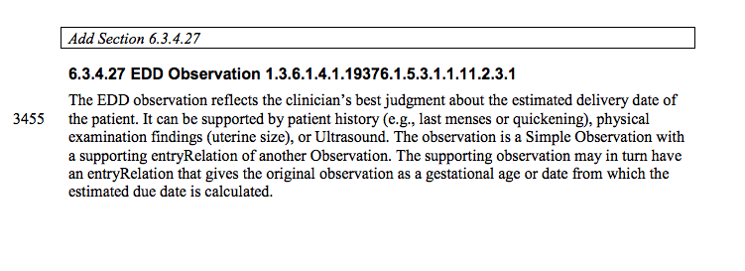
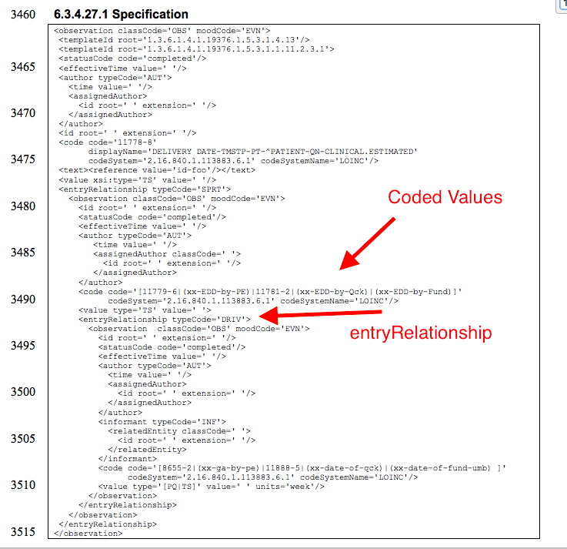

The figure below is OxygenXML validating the example file against the CDA 2010 schema definition.
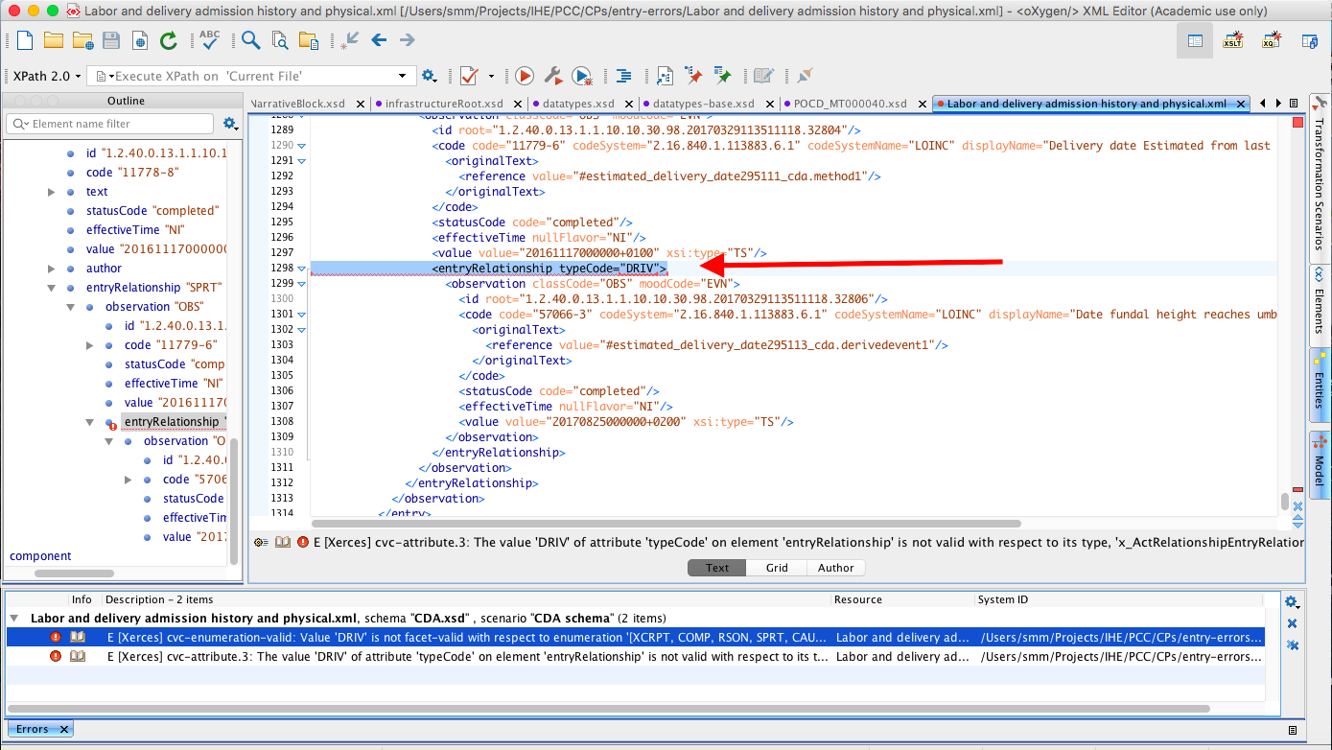

Add the following section after Section : 6.3.4.27.1
1) Address by replacing the tempoary codes in the XML sample located at 6.3.4.27.1 with the codes that are defined in the table under section 6.3.4.27.10:
xx-EDD-by-Qck = 57063-0
xx-EDD-by-Fund = 57064-8
xx-EDD-by-PE = Requested from LOINC

2) Addressed in CP-PCC-0265

3) *Not specifically requested in CP, but added to resolution*
We will also replace the existing code for GESTATIONAL AGE-TIME-PT-^FETUS-QN-ESTIMATED FROM CLINICIANS PHYSICAL EXAM M in the table under section 6.3.4.27.13 with a new code to be requested from LOINC. This is due to the fact that the code currently included here (11884-4) is not appropriate for this concept.

